**Week 3**

Exercise 1: Configuring a Basic Spring Application

**App.config.java**

package com.example;

import org.springframework.context.annotation.Bean;

import org.springframework.context.annotation.Configuration;

@Configuration

public class AppConfig {

@Bean

public MyService myService() {

return new MyService();

}

}

**MainApp.java**

package com.example;

import org.springframework.context.ApplicationContext;

import org.springframework.context.annotation.AnnotationConfigApplicationContext;

public class MainApp {

public static void main(String[] args) {

ApplicationContext context = new AnnotationConfigApplicationContext(AppConfig.class);

MyService service = context.getBean(MyService.class);

service.doSomething();

}

}

**MyService.java**

**package** com.example;

**public** **class** MyService {

**public** **void** doSomething() {

System.***out***.println("Hello from MyService!");

}

}

**Exercise 2: Implementing Dependency Injection**

**Application.java**

**package** com.example.exercise2_dependencyinjection;

**import** org.springframework.boot.SpringApplication;

**import** org.springframework.boot.autoconfigure.SpringBootApplication;

@SpringBootApplication

**public** **class** Application {

**public** **static** **void** main(String[] args) {

SpringApplication.*run*(Application.**class**, args);

}

}

**GreetingControler.java**

package com.example.exercise2_dependencyinjection;

import org.springframework.beans.factory.annotation.Autowired;

import org.springframework.web.bind.annotation.GetMapping;

import org.springframework.web.bind.annotation.RestController;

@RestController

public class GreetingController {

@Autowired

private GreetingService greetingService;

@GetMapping("/greet")

public String greet() {

return greetingService.greet();

}

}

**GreetingService.java**

**package** com.example.exercise2_dependencyinjection;

**public** **interface** GreetingService {

String greet();

}

**GreetingServiceimpl.java**

**package** com.example.exercise2_dependencyinjection;

**import** org.springframework.stereotype.Service;

@Service

**public** **class** GreetingServiceImpl **implements** GreetingService {

**public** String greet() {

**return** "Hello, Spring Dependency Injection!";

}

}

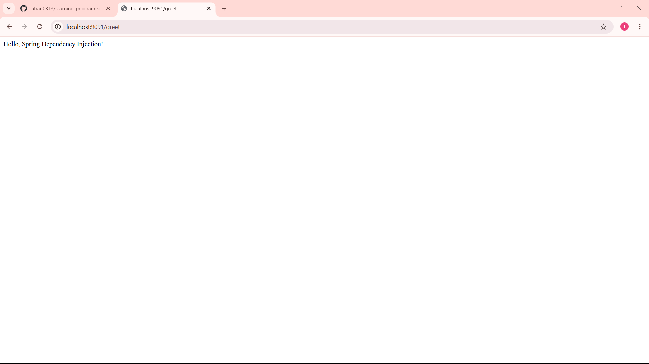

**Exercise 4: Creating and Configuring a Maven Project**

**Application.java**

package com.example.exercise4;

import org.springframework.boot.SpringApplication;

import org.springframework.boot.autoconfigure.SpringBootApplication;

@SpringBootApplication

public class Application {

public static void main(String[] args) {

SpringApplication.run(Application.class, args);

}

}

**HelloControler.java**

**package** com.example.exercise4;

**import** org.springframework.web.bind.annotation.GetMapping;

**import** org.springframework.web.bind.annotation.RestController;

@RestController

**public** **class** HelloController {

@GetMapping("/")

**public** String home() {

**return** "Welcome to Exercise 4: Maven Project!";

}

}

## Spring Data JPA with Spring Boot & Hibernate

## Task 4 – Implement Services for Managing Country

## CountryService.java

package com.example;  
  
public class CountryService {  
 public void manage() {  
 System.out.println("Managing Country...");  
 }  
}

## MainApp.java

package com.example;

public class MainApp {

public static void main(String[] args) {

CountryRepository repo = new CountryRepository();

System.***out***.println("Country for IN: " + repo.findByCode("IN"));

}

}

## ----------------------------------------------------------------------------------Task 5 – Find Country Based on Country Code

## MainApp.java

package com.example;

public class MainApp {

public static void main(String[] args) {

CountryRepository repo = new CountryRepository();

System.***out***.println("Country for IN: " + repo.findByCode("IN"));

}

}

## CountryRepository.java

package com.example;  
  
public interface CountryRepository {  
 String findByCode(String code);  
}

## Task 6 – Add a New Country

## AddCountry.java

package com.example;  
  
public class AddCountry {  
 public void add(String code, String name) {  
 System.out.println("Country added: " + code + ", " + name);  
 }  
}

## **MainApp.java**

package com.example;  
  
public class MainApp {  
 public static void main(String[] args) {  
 AddCountry adder = new AddCountry();  
 adder.add("FR", "France");  
 }  
}

## **Task 7 – Demonstrate Query Methods**

## **QueryMethods.java**

package com.example;  
  
public class QueryMethods {  
 public String findByName(String name) {  
 return "Simulated result for name: " + name;  
 }  
}

## **MainApp.java**

package com.example;  
  
public class MainApp {  
 public static void main(String[] args) {  
 QueryMethods qm = new QueryMethods();  
 System.out.println(qm.findByName("India"));  
 }  
}

## **Task 8 – Demonstrate O/R Mapping**

## **Country.java**

package com.example;  
  
import jakarta.persistence.Entity;  
import jakarta.persistence.Id;  
  
@Entity  
public class Country {  
 @Id  
 private String code;  
 private String name;  
  
 public Country() {}  
 public Country(String code, String name) {  
 this.code = code;  
 this.name = name;  
 }  
  
 public String toString() {  
 return "Country{" + "code='" + code + "', name='" + name + "'}";  
 }  
}

## **MainApp.java**

package com.example;  
  
public class MainApp {  
 public static void main(String[] args) {  
 Country c = new Country("DE", "Germany");  
 System.out.println(c);  
 }  
}

## **Task 9 – Write HQL & Native Queries**

## **HQLExample.java**

package com.example;  
  
public class HQLExample {  
 public void run() {  
 System.out.println("Simulating execution of HQL and Native Queries...");  
 }  
}

## **MainApp.java**

package com.example;  
  
public class MainApp {  
 public static void main(String[] args) {  
 HQLExample hql = new HQLExample();  
 hql.run();  
 }  
}

